***Annual Picnic Report of the Department of Computer Science and Engineering (CSE) & the Department of Microbiology, Notre Dame University Bangladesh (NDUB)***

Both the Department of Computer Science and Engineering (CSE) & the Department of Microbiology at Notre Dame University Bangladesh (NDUB) organized its annual picnic on 25th February 2025 at Chuti Resort. The event was convened by Afsana Sharmin Shanta, lecturer, with other faculty members and students of both departments who worked together to make the event graceful for all the participants. To add a special touch, custom T-shirts were arranged for the participants, making the day event more colorful.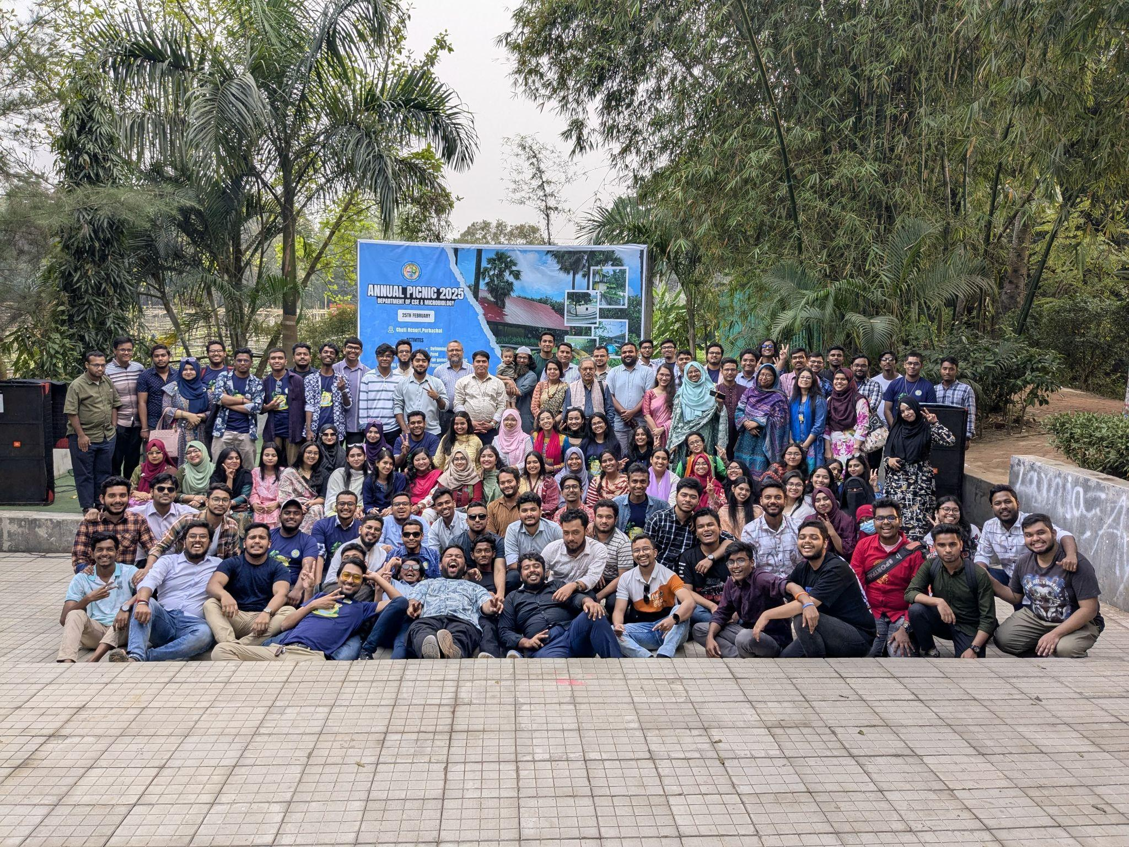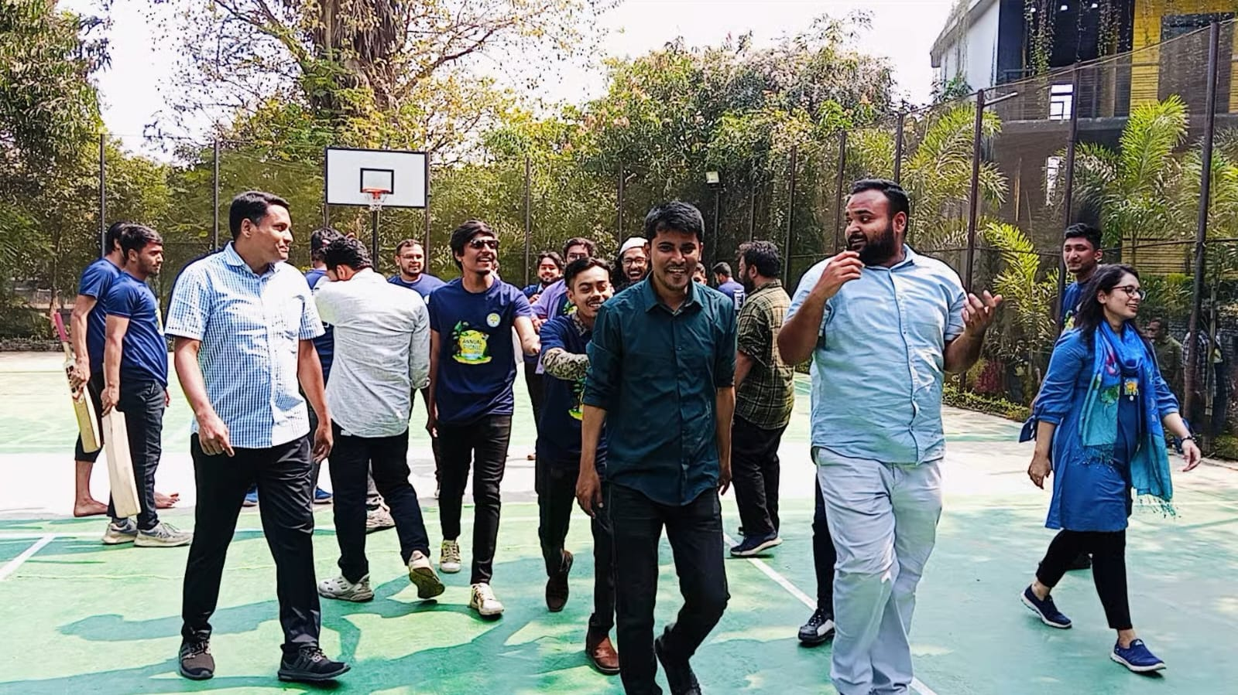

The day began with buses departing from the NDUB campus at 8:00AM, and snacks were provided during the journey to keep everyone energized, and the group arrived at the venue by 10:30AM. Upon arrival, participants were welcomed with a delicious breakfast. After breakfast, some of the students eagerly explored the resort, some of the students were busy playing football and cricket, and some were busy jumping in the pool, as there was separate swimming pool time for both male and female students.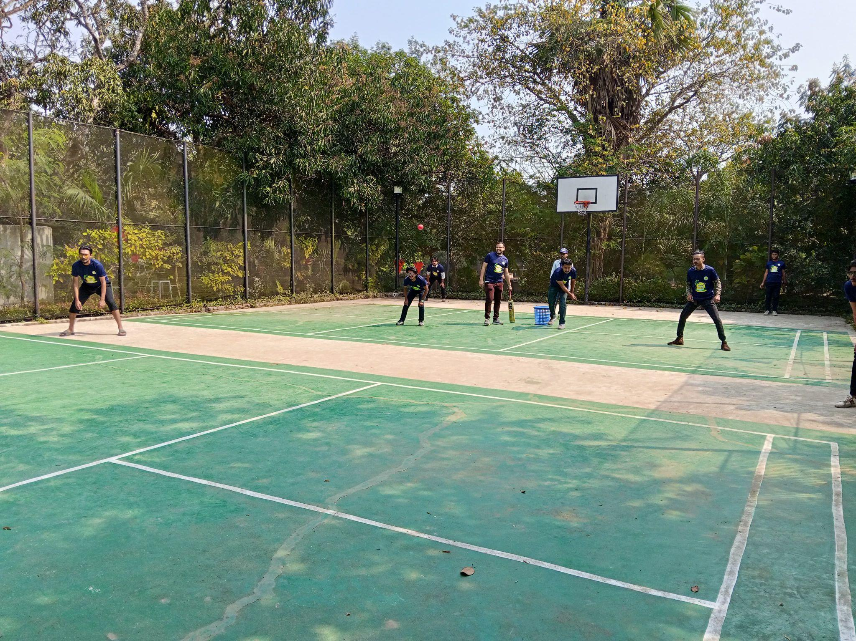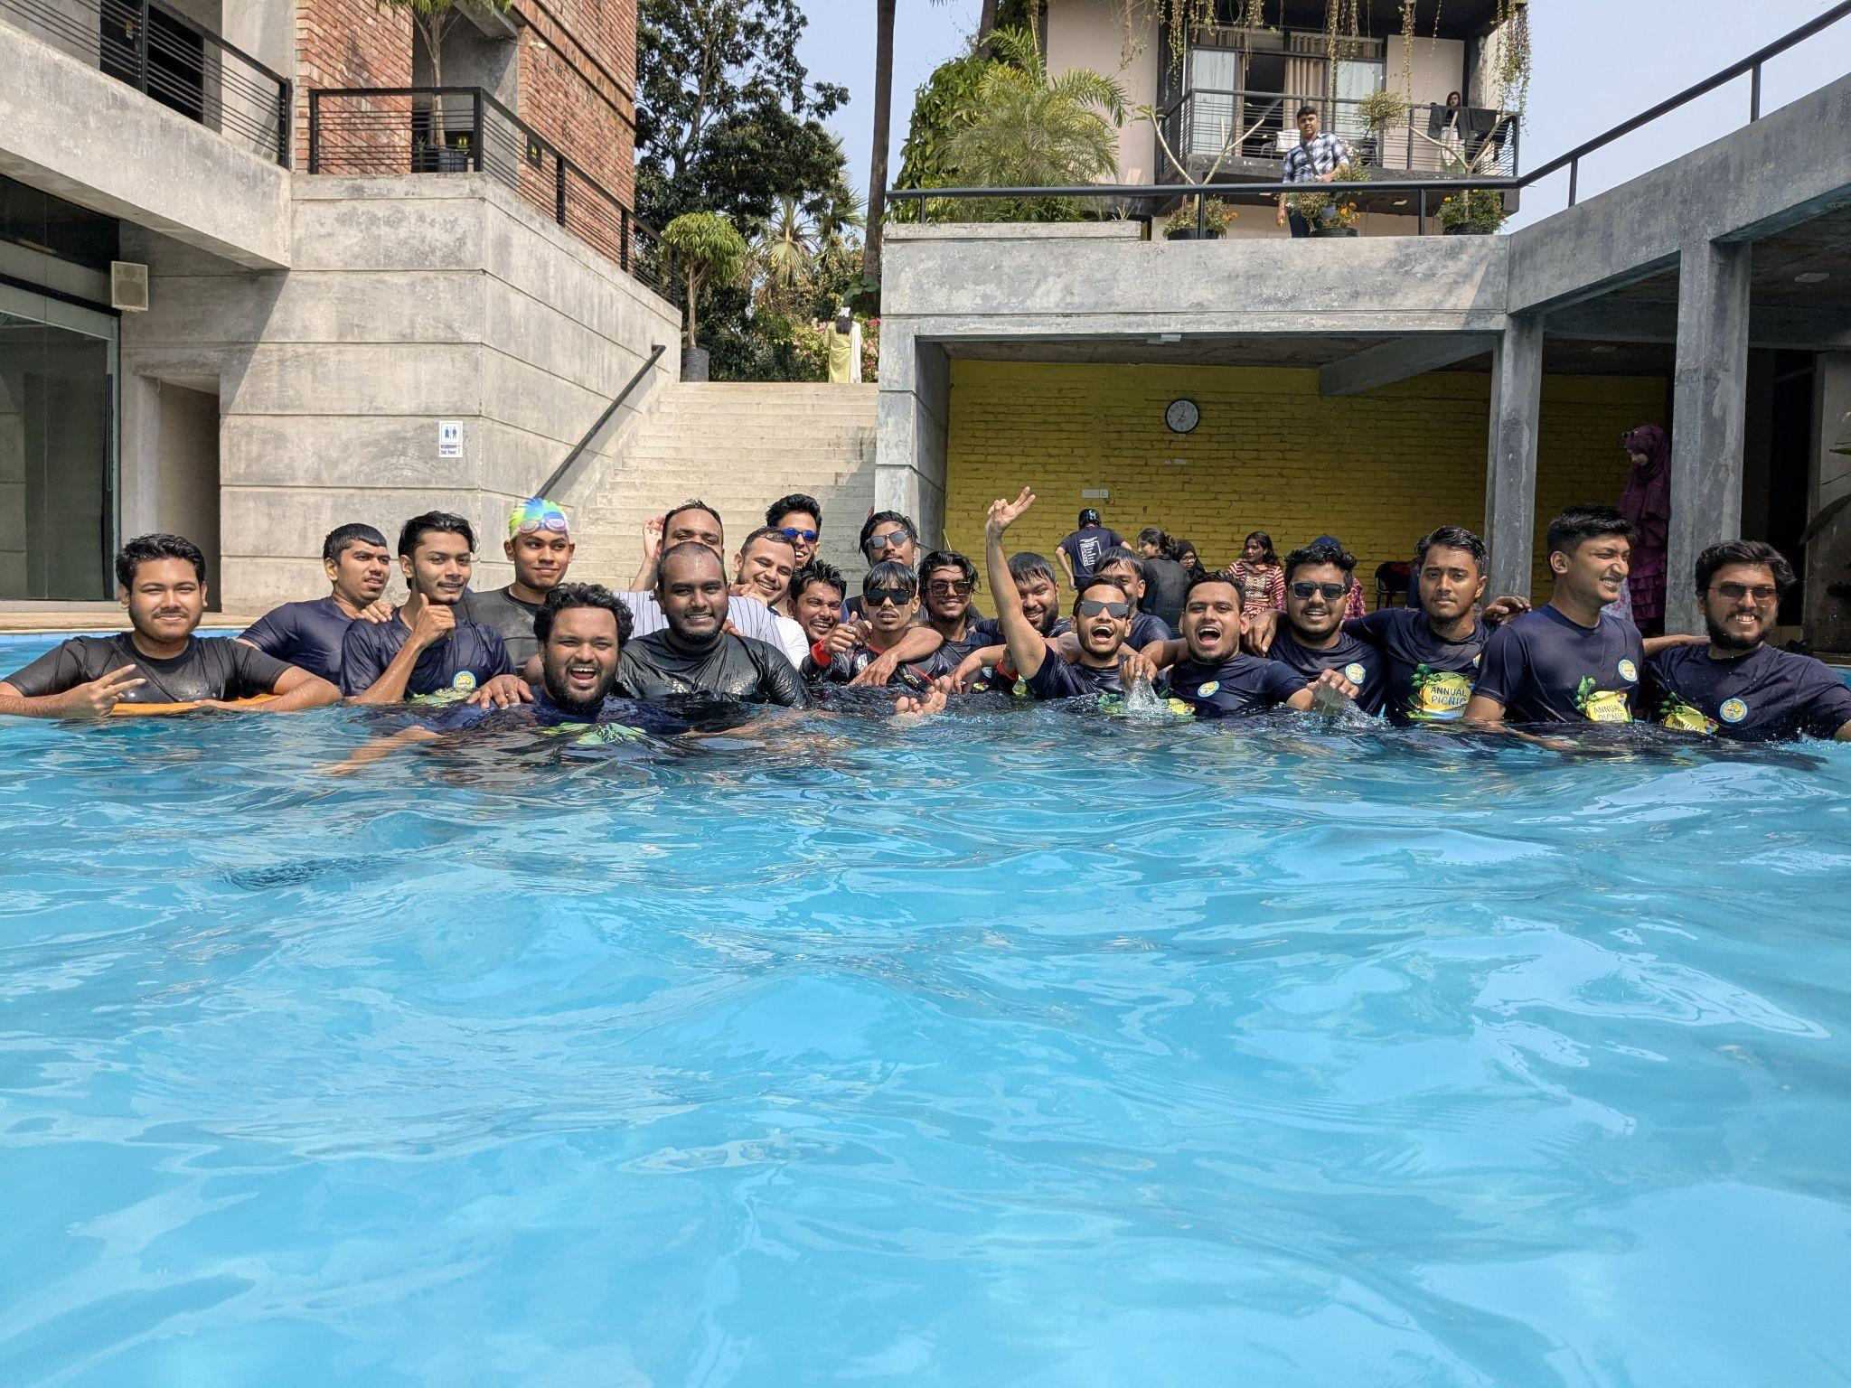

By 2:00PM, after a fun-filled morning, everyone gathered for lunch. The excitement continued with a cultural program that began at 4:00 pm. The program was graced by the presence of the Chief Guest, Honorable Deputy Registrar, Fr. Ashim Theotonius Gonsalves, CSC. He was warmly welcomed with flowers and gifts.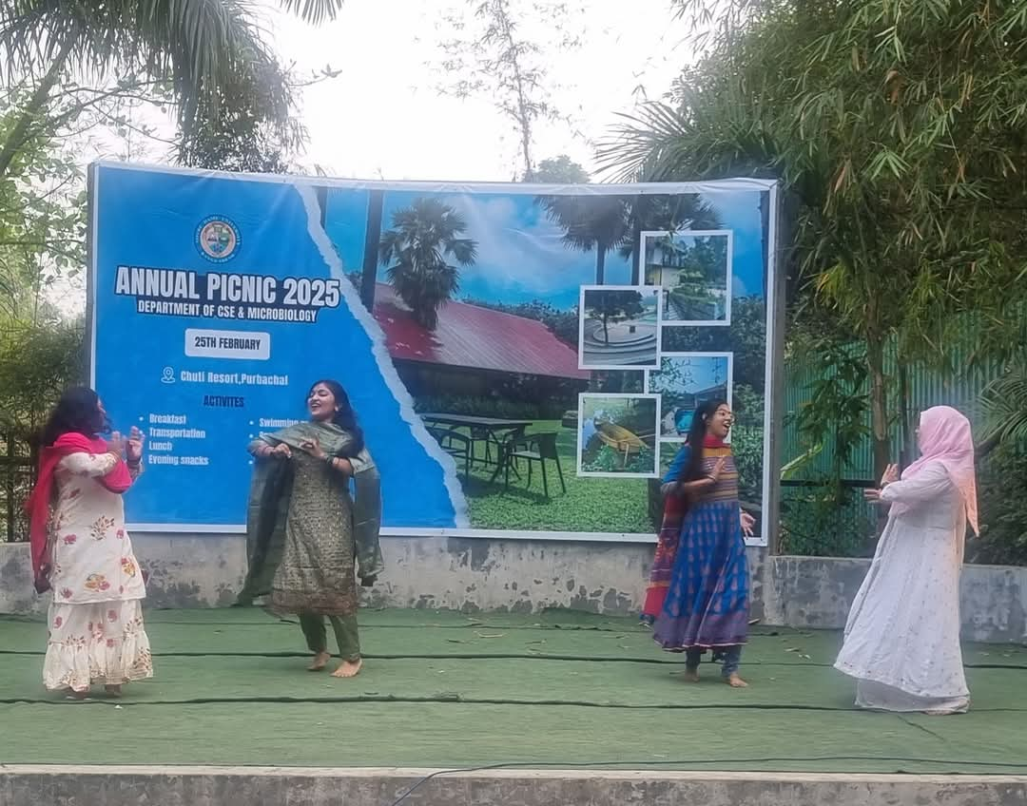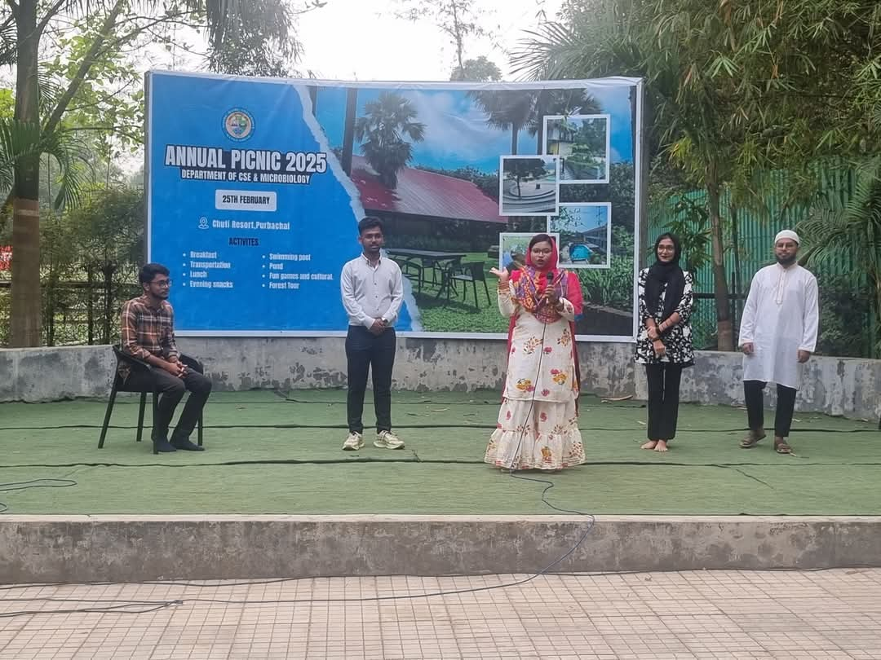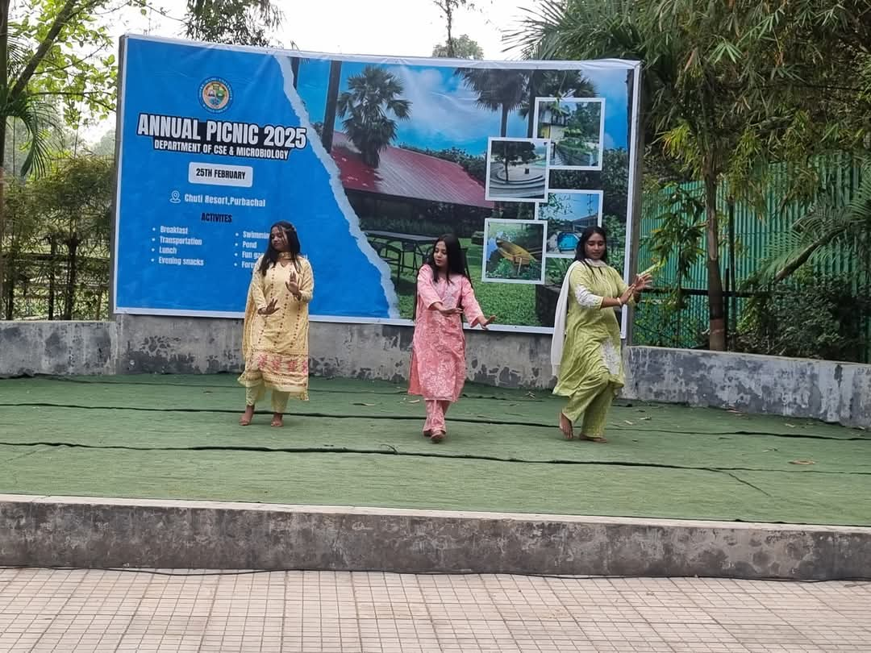

The cultural program was a highlight of the day, featuring songs, dances, and dramas performed by students. Additional activities, such as a cricket match between teachers and students and various games, added to the enjoyment. All the events were completed smoothly and according to the schedule; snacks were provided to keep everyone refreshed.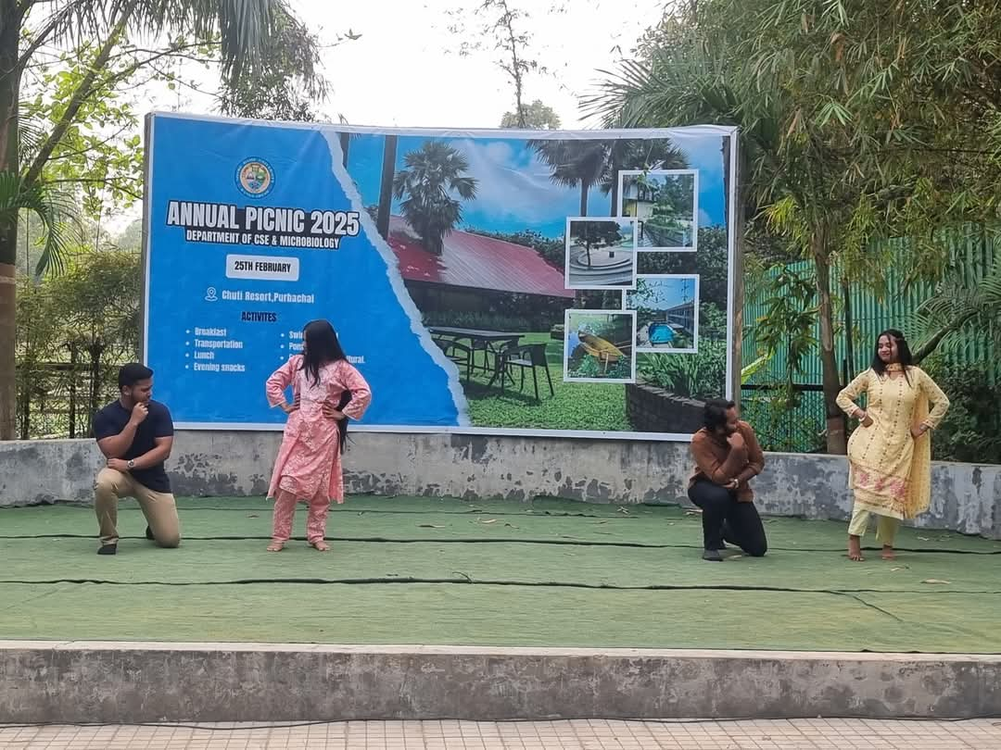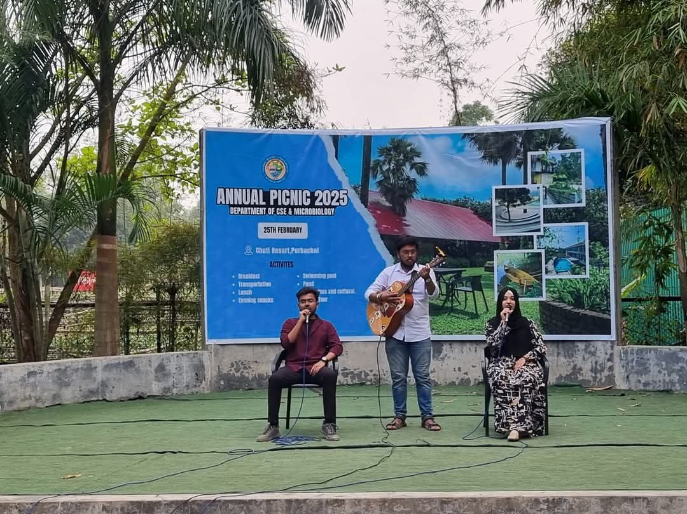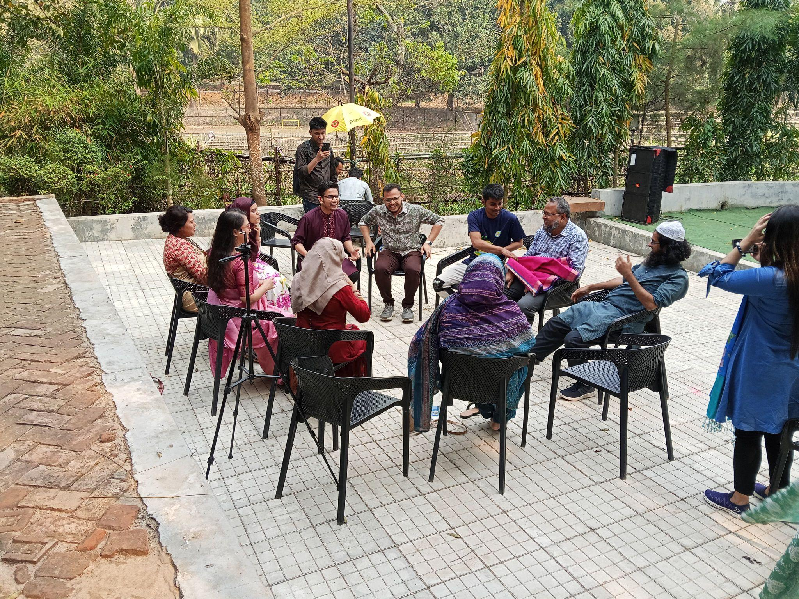

To preserve the memories of this special day, group photos were taken with all the students and faculty members. The picnic came to an end at 6:00PM, and the group returned to the NDUB campus by 9:00PM, filled with joy and satisfaction.

Both departments would like to extend their heartfelt gratitude to the NDUB authority, faculty members, and students for their cooperation and support in making this event a grand success. The picnic not only provided a break from academic routines but also strengthened the bond among NDUB CSE family members, creating unforgettable memories for everyone involved.